Volatility Tracking
Measuring, Forecasting and Trading the Market's Temperature
A Level 3 module in the Quantitative Finance Curriculum (revisited at Level 5)
Covers: Realized volatility · Historical volatility estimators · Volatility clustering · EWMA · GARCH · HAR-RV · Implied volatility · Volatility surface · Skew & smile · Term structure · VIX · Variance swaps · Volatility risk premium · Mean reversion · Regime shifts · Volatility targeting · Vol-of-vol · Rough volatility · Volatility arbitrage · Risk management

Table of Contents
How to Use This Guide 3
What You Need to Know Before Starting 3
Why It Matters 3
How This Connects to the Rest of the Curriculum 3
Glossary of Recurring Terms 4
Part 1 — Measuring Volatility: From Historical to Realized 5
1.1 Close-to-Close (Historical) Volatility 5
1.2 Range-Based Estimators 5
1.3 Realized Volatility from High-Frequency Data 6
1.4 Stylized Facts: Clustering, Fat Tails and Leverage 6
Part 2 — Forecasting Volatility 8
2.1 Exponentially Weighted Moving Average 8
2.2 The GARCH Family 8
2.3 The HAR-RV Model 8
2.4 Comparing and Evaluating Forecasts 9
Part 3 — Implied Volatility and the Volatility Surface 11
3.1 From Option Prices to Implied Volatility 11
3.2 The Volatility Smile and Skew 11
3.3 Term Structure and the Full Surface 12
3.4 Parameterizing the Surface: SVI 12
Part 4 — Volatility as an Asset Class 13
4.1 The VIX and Variance Swap Replication 13
4.2 The Volatility Risk Premium 13
4.3 Trading Volatility 14
Part 5 — Volatility Tracking in Practice 15
5.1 Volatility Targeting in Portfolio Construction 15
5.2 Volatility Scaling in Risk Management 15
5.3 Regime Detection and Nowcasting 16
5.4 Data and Infrastructure Conventions 16
Practical Exercise 17
Common Beginner Mistakes 18
Advanced Extensions 19
Professional Applications 20
Where to Go Next 21

How to Use This Guide

What You Need to Know Before Starting
This module assumes comfort with the following foundational areas:
- Statistics — variance, standard deviation, autocorrelation and maximum likelihood estimation recur throughout every volatility model in this module.
- Time-Series Analysis — stationarity, autoregressive structure and rolling estimation underpin both historical measurement and forecasting.
- Derivatives — Core Pricing — the Black-Scholes framework is the lens through which implied volatility is defined and extracted from option prices.
- Risk Metrics — volatility is the primary input to value-at-risk, position sizing and portfolio scaling, all covered in Part 5.
- Probability & Stochastic Processes — Brownian motion, quadratic variation and conditional expectation are the mathematical language of realized and stochastic volatility.
- Optimisation — fitting GARCH parameters or a volatility surface by maximum likelihood or least squares is an optimisation problem under constraints.
Tip: Volatility tracking sits at the intersection of statistics and options theory. If the Black-Scholes formula or the idea of a rolling standard deviation feels unfamiliar, a quick refresher will make Parts 2 and 3 far easier to follow.

Why It Matters
Volatility is the single most important number in quantitative finance that is not a price. It determines how options are priced, how much capital a position consumes, how large a portfolio's positions should be, and how much confidence to place in any risk estimate. Unlike price, volatility cannot be observed directly — it must be estimated from historical data, inferred from option prices, or forecast from a model, and each of these three routes can give a different answer at the same moment in time. Volatility is also not constant: it clusters, mean-reverts, jumps around news, and moves through recognisably different regimes. Tracking it well — measuring it accurately today and forecasting it credibly tomorrow — is a discipline in its own right, and one that touches research, trading and risk management simultaneously.

How This Connects to the Rest of the Curriculum
- Connects to Research: volatility forecasts feed option pricing, risk models, factor construction and every strategy that scales positions by risk rather than by notional.
- Connects to Development: volatility-tracking systems require high-frequency data handling, careful annualisation conventions, and infrastructure for maintaining and updating a volatility surface in real time.
- Connects to Trading: volatility is directly tradable through options, variance swaps and the VIX complex, and indirectly drives position sizing, hedge ratios and margin requirements across every other market.

Glossary of Recurring Terms
- Historical volatility: The standard deviation of past returns over a chosen window, typically annualised by scaling by the square root of the number of periods per year.
- Realized volatility: A measure of volatility computed from observed price data — either daily closes or high-frequency intraday returns — as an estimate of the true, unobservable variance of the process.
- Implied volatility: The volatility that, when input into an option pricing model, reproduces the option's observed market price; a market-implied forecast rather than a historical measurement.
- Volatility clustering: The empirical tendency for large price moves to be followed by more large moves, and calm periods to be followed by more calm — the reason volatility is forecastable at all.
- Mean reversion (in volatility): The tendency for volatility to drift back toward a long-run average level after a shock, rather than remaining permanently elevated or depressed.
- Leverage effect: The empirical tendency for volatility to rise more after a price fall than after a price rise of the same size, linked to increased financial leverage as equity values decline.
- EWMA: Exponentially weighted moving average — a volatility forecast that weights recent squared returns more heavily than older ones, with weights decaying geometrically.
- GARCH: Generalised autoregressive conditional heteroskedasticity — a model family in which today's variance depends on yesterday's variance and yesterday's squared return.
- HAR-RV: The heterogeneous autoregressive model of realized volatility, which forecasts volatility from a cascade of daily, weekly and monthly realized-volatility components.
- Volatility surface: The full grid of implied volatilities across every combination of strike and maturity traded on an underlying.
- Volatility smile / skew: The pattern by which implied volatility varies with strike at a fixed maturity — a smile is symmetric around the money; a skew is asymmetric, as is typical in equity index options.
- Term structure of volatility: The pattern by which implied (or realized) volatility varies with maturity, holding moneyness fixed.
- VIX: The Cboe Volatility Index, a model-free measure of 30-day implied volatility on the S&P 500, constructed by replicating a variance swap from a strip of listed options.
- Variance swap: A forward contract on realized variance, paying the difference between realized variance over the contract period and a fixed strike agreed at inception.
- Volatility risk premium (VRP): The tendency for implied volatility to exceed subsequently realized volatility on average, compensating sellers of volatility for bearing tail risk.
- Vol-of-vol: The volatility of the volatility process itself — how much the level of volatility fluctuates, relevant to pricing options on volatility and to the convexity of the surface.
- Volatility targeting: A portfolio-construction rule that scales position size inversely with forecast volatility so that the portfolio's realized risk stays near a fixed target.
- Rough volatility: The empirical finding that log-volatility behaves like a fractional Brownian motion with a Hurst exponent well below 0.5, i.e. a much rougher (less smooth) path than classical diffusion models assume.

Part 1 — Measuring Volatility: From Historical to Realized
Before volatility can be forecast, traded or hedged, it has to be measured. This sounds simple but is not: the same underlying price process can produce noticeably different volatility numbers depending on whether the estimator uses only closing prices, the full daily range, or the entire path of high-frequency trades. This part works through the main historical and realized estimators used in industry, in increasing order of statistical efficiency.

1.1 Close-to-Close (Historical) Volatility
The simplest and most widely reported volatility measure uses only daily closing prices. For log returns rₜ = ln(Cₜ / Cₜ₋₁) over a window of N days, the sample standard deviation is annualised by the square root of the number of trading periods per year:
σ²_CC = (1 / (N-1)) × Σ (r_t − r̄)²
σ_annual = σ_CC × √252 (daily data, 252 trading days/year)
Close-to-close volatility is simple, universally available and the natural benchmark, but it uses only one data point per day. Everything that happened between the previous close and today's close — the entire intraday range, and any overnight gap — is compressed into a single number, which makes the estimator noisy relative to how much price information was actually available.

1.2 Range-Based Estimators
Because the daily high and low contain real information about how much a price actually moved intraday, a family of range-based estimators has been developed to extract more efficiency from the same OHLC (open-high-low-close) data. Each makes a different assumption about drift and overnight gaps.
Estimator | Idea | Handles overnight gaps | Handles drift
Parkinson (1980) | Uses only the high-low range, assuming continuous trading and zero drift. | No | Assumes zero drift
Garman-Klass (1980) | Combines the high-low range with the open-close move for extra efficiency. | No | Assumes zero drift
Rogers-Satchell (1991) | A range-based measure explicitly constructed to be unbiased under non-zero drift. | No | Drift-independent
Yang-Zhang (2000) | Sums an overnight (close-to-open) variance term with a weighted blend of open-to-close and Rogers-Satchell variance. | Yes | Drift-independent
The Yang-Zhang estimator is generally regarded as the most statistically efficient of the group, because it is the only one that is simultaneously drift-independent and aware of overnight gaps:
σ²_YZ = σ²_overnight + k × σ²_open-to-close + (1 − k) × σ²_Rogers-Satchell
where k = 0.34 / (1.34 + (N+1)/(N−1))
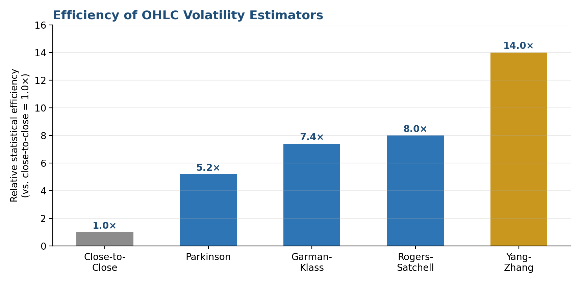
Figure 1.1. Relative statistical efficiency of common OHLC volatility estimators, expressed as a multiple of close-to-close. Yang-Zhang extracts roughly 14 times as much information from the same number of trading days.
Tip: A large gap between the Yang-Zhang estimate and close-to-close on the same window is itself informative: it signals that a meaningful share of the asset's total variance is arriving overnight rather than during the trading session.

1.3 Realized Volatility from High-Frequency Data
When intraday (tick or minute-bar) data is available, volatility can be estimated directly as the sum of squared high-frequency returns over a day — the realized variance:
RV_t = Σᵢ₌₁^M r²_{t,i} (sum of M squared intraday log-returns on day t)
RV_annual = √(252 × RV_t)
As the sampling frequency increases, realized variance converges to the quadratic variation of the underlying price process — its theoretically ‘true’ variance over that day. In practice, sampling too finely reintroduces noise from bid-ask bounce and other microstructure effects, so realized volatility is usually computed from 1-to-5-minute returns rather than tick-by-tick data, or corrected using techniques such as realized kernels or pre-averaging.
Tip: Realized volatility built from intraday data is the standard input to modern forecasting models such as HAR-RV, precisely because it is dramatically more efficient than a single daily close-to-close observation.

1.4 Stylized Facts: Clustering, Fat Tails and the Leverage Effect
Whichever estimator is used, financial return series share a set of well-documented empirical regularities, often called the stylized facts of volatility. The most important for tracking purposes is volatility clustering: large moves tend to be followed by more large moves, and calm periods by more calm, so that volatility is autocorrelated even when returns themselves are close to unpredictable. A second regularity is the leverage effect: volatility tends to rise more after a price decline than after a price increase of the same size. Together, these facts are why volatility is forecastable even though returns are close to a random walk.
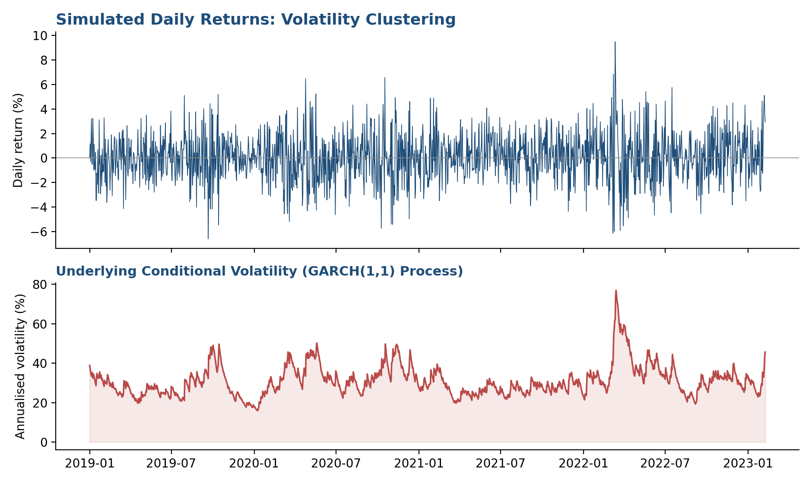
Figure 1.2. A simulated GARCH(1,1) return series (top) and its underlying conditional volatility (bottom). Note how periods of large returns coincide with visibly elevated and persistent volatility — the defining signature of volatility clustering.
Common mistake: Assuming that because daily returns are close to unpredictable, volatility must be unpredictable too. The two are different objects: the sign and size of tomorrow's return is hard to forecast, but the magnitude of the volatility that generates it is highly persistent and forecastable — that persistence is the entire basis of Part 2.

Part 2 — Forecasting Volatility
Because volatility clusters and mean-reverts, its recent history contains real information about tomorrow. This part covers the three forecasting approaches most widely used in practice: the simple exponentially weighted moving average, the GARCH family that explicitly models the volatility process, and the more recent HAR-RV model built directly on realized volatility.

2.1 Exponentially Weighted Moving Average
The EWMA approach, popularised by RiskMetrics, forecasts tomorrow's variance as a weighted average of today's forecast and today's squared return, with weights decaying geometrically at a decay factor λ:
σ²_t = λ × σ²_{t-1} + (1 − λ) × r²_{t-1}
RiskMetrics standard: λ = 0.94 (daily data), λ = 0.97 (monthly data)
EWMA requires no parameter estimation beyond choosing λ, updates with a single new observation, and is simple enough to run in a spreadsheet. Its main limitation is that it has no mean-reversion target: a volatility shock persists with the same geometric decay indefinitely, rather than being pulled back toward a long-run average, which tends to make EWMA forecasts slower to fall after a spike than models that build in mean reversion explicitly.

2.2 The GARCH Family
The GARCH(1,1) model of Bollerslev (1986), building on Engle's original ARCH (1982), makes the mean-reversion target explicit by adding a constant term:
σ²_t = ω + α × r²_{t-1} + β × σ²_{t-1}
long-run variance = ω / (1 − α − β) (requires α + β < 1)
Here α governs how strongly a fresh shock moves the forecast, and β governs how persistent that effect is. GARCH is typically fit by maximum likelihood on daily returns, and its parameters can be read directly for insight: a high β (often above 0.85 for equity indices) means shocks decay slowly; α + β close to one means volatility is highly persistent, near the boundary of covariance-stationarity. Numerous extensions — EGARCH and GJR-GARCH, in particular — add an explicit asymmetry term to capture the leverage effect directly, rather than relying on the symmetric response of plain GARCH(1,1).

2.3 The HAR-RV Model
Corsi (2009) proposed a different route: rather than modelling variance as a latent process driven by squared returns, regress future realized volatility directly on realized volatility measured over three different horizons — daily, weekly and monthly. The model is motivated by the heterogeneous market hypothesis, the idea that traders operating on different time horizons perceive and react to volatility differently, with longer-horizon volatility influencing short-horizon behaviour more than the reverse:
RV_{t+1} = β₀ + β_d × RV_t + β_w × RV_t^(w) + β_m × RV_t^(m) + ε_{t+1}
RV_t^(w) = average of RV over the past 5 days
RV_t^(m) = average of RV over the past 22 days
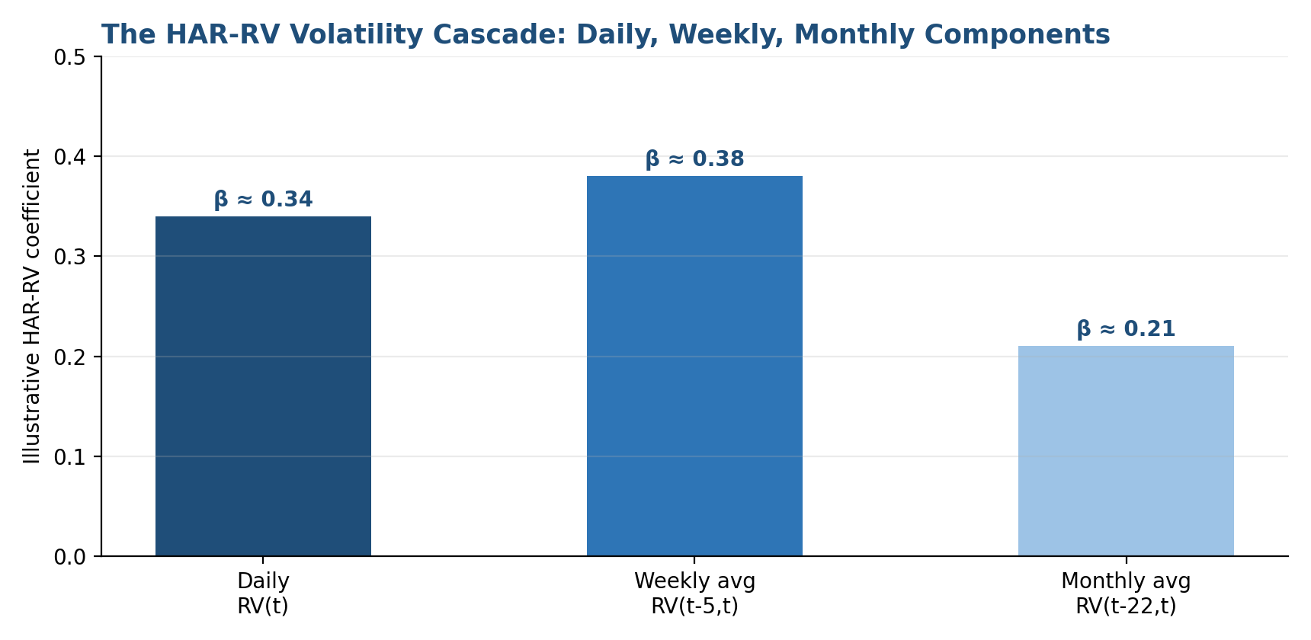
Figure 2.1. The HAR-RV volatility cascade: illustrative coefficients on the daily, weekly and monthly realized-volatility components. All three horizons typically carry meaningful, statistically significant weight.
Despite being nothing more than an ordinary least-squares regression with three predictors, HAR-RV reproduces the long-memory-like slow decay of volatility autocorrelation observed empirically, and has repeatedly been shown to forecast realized volatility at least as well as much more heavily parameterised GARCH-type models — while remaining transparent enough that every coefficient has a direct economic interpretation.

2.4 Comparing and Evaluating Forecasts
In practice, a volatility desk rarely commits to a single model. EWMA, GARCH and HAR-RV forecasts are typically tracked side by side against subsequently realized volatility, both to sanity-check each other and because their disagreement is itself informative — wide dispersion between models often flags a regime change in progress.
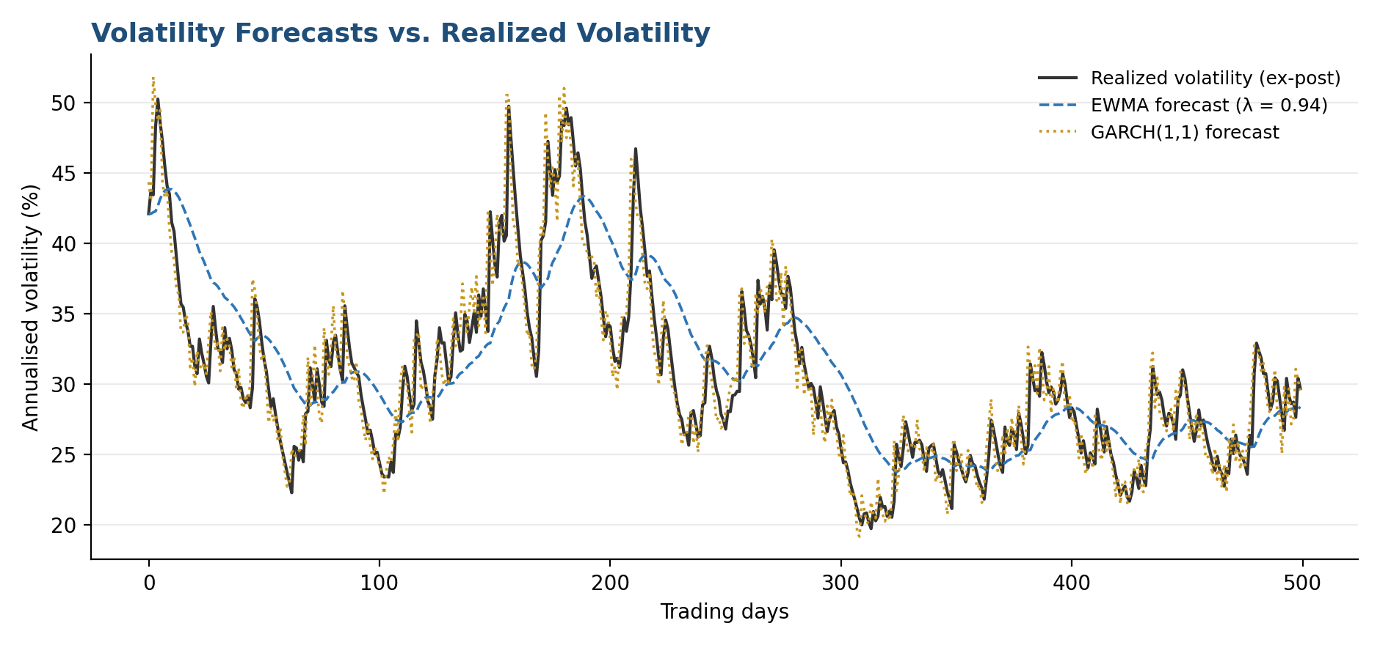
Figure 2.2. EWMA and GARCH(1,1) forecasts plotted against subsequently realized volatility. EWMA lags turning points more visibly than GARCH, which mean-reverts back toward its long-run level after a shock.
Tip: Evaluate volatility forecasts the same way you would any forecast: out-of-sample, against a proper scoring rule such as mean squared error or QLIKE on the forecast variance, not by eyeballing how well a fitted line tracks the data it was fitted on.

Part 3 — Implied Volatility and the Volatility Surface
Historical and realized volatility describe the past. Implied volatility describes what the options market is currently pricing in for the future — a genuinely different, forward-looking measurement extracted not from returns but from option prices themselves.

3.1 From Option Prices to Implied Volatility
The Black-Scholes formula prices a European option as a function of five inputs: spot, strike, time to maturity, the risk-free rate, and volatility. Implied volatility inverts this relationship — given an observed market price, it is the single value of σ that makes the Black-Scholes price match the market:
C_BS(S, K, T, r, σ) = C_market
⇒ solve for σ numerically (Newton-Raphson or bisection; no closed form exists)
Because Black-Scholes assumes constant volatility and log-normal returns — assumptions that are known to be wrong — implied volatility is best understood not as a genuine forecast of future realized volatility under those assumptions, but as a convenient, standardised unit for quoting an option's price. Two options on the same underlying at different strikes or maturities are directly comparable once their prices are converted into this common unit.

3.2 The Volatility Smile and Skew
If Black-Scholes' assumptions held exactly, every option on the same underlying and maturity would imply the same volatility regardless of strike. In practice they do not: equity index options typically show a pronounced skew, with implied volatility rising steadily as strikes fall further out-of-the-money on the put side, reflecting the market's persistent demand for downside protection and the empirical fact that large equity moves are more often to the downside.
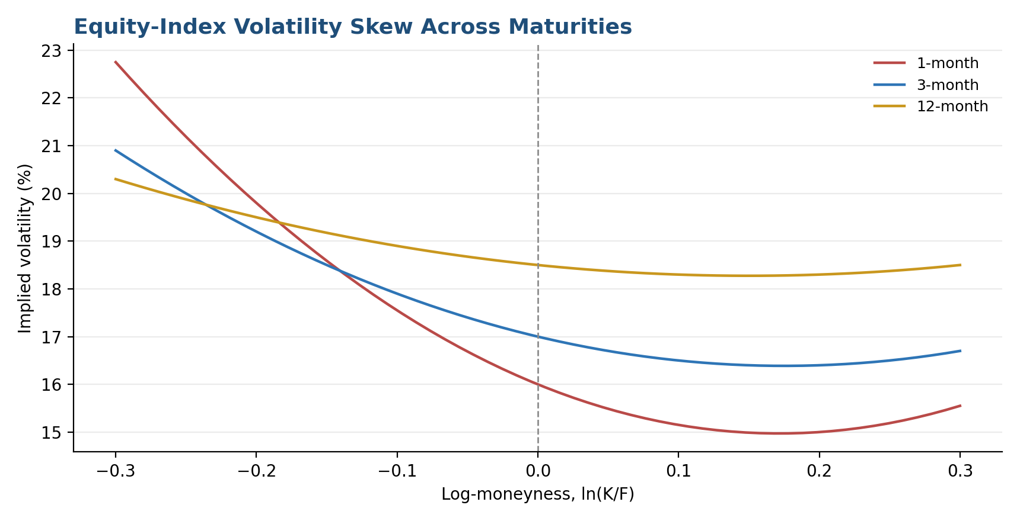
Figure 3.1. Illustrative equity-index implied volatility skew across three maturities. The skew is steepest at short maturities and flattens — though never disappears — as maturity lengthens.
Common mistake: Treating a strike's implied volatility as if it were a forecast of realized volatility for that particular payoff. Skew reflects supply and demand for tail protection as much as it reflects a statistical view about the distribution of future returns.

3.3 Term Structure and the Full Surface
Implied volatility also varies with maturity at a fixed moneyness — its term structure. Short-dated options are more sensitive to near-term events (earnings, central bank meetings) and tend to be more volatile in their own right, while longer-dated implied volatility reflects a smoothed average of expected variance further into the future. Combining the strike dimension and the maturity dimension produces the full volatility surface, the object that a derivatives desk actually manages.
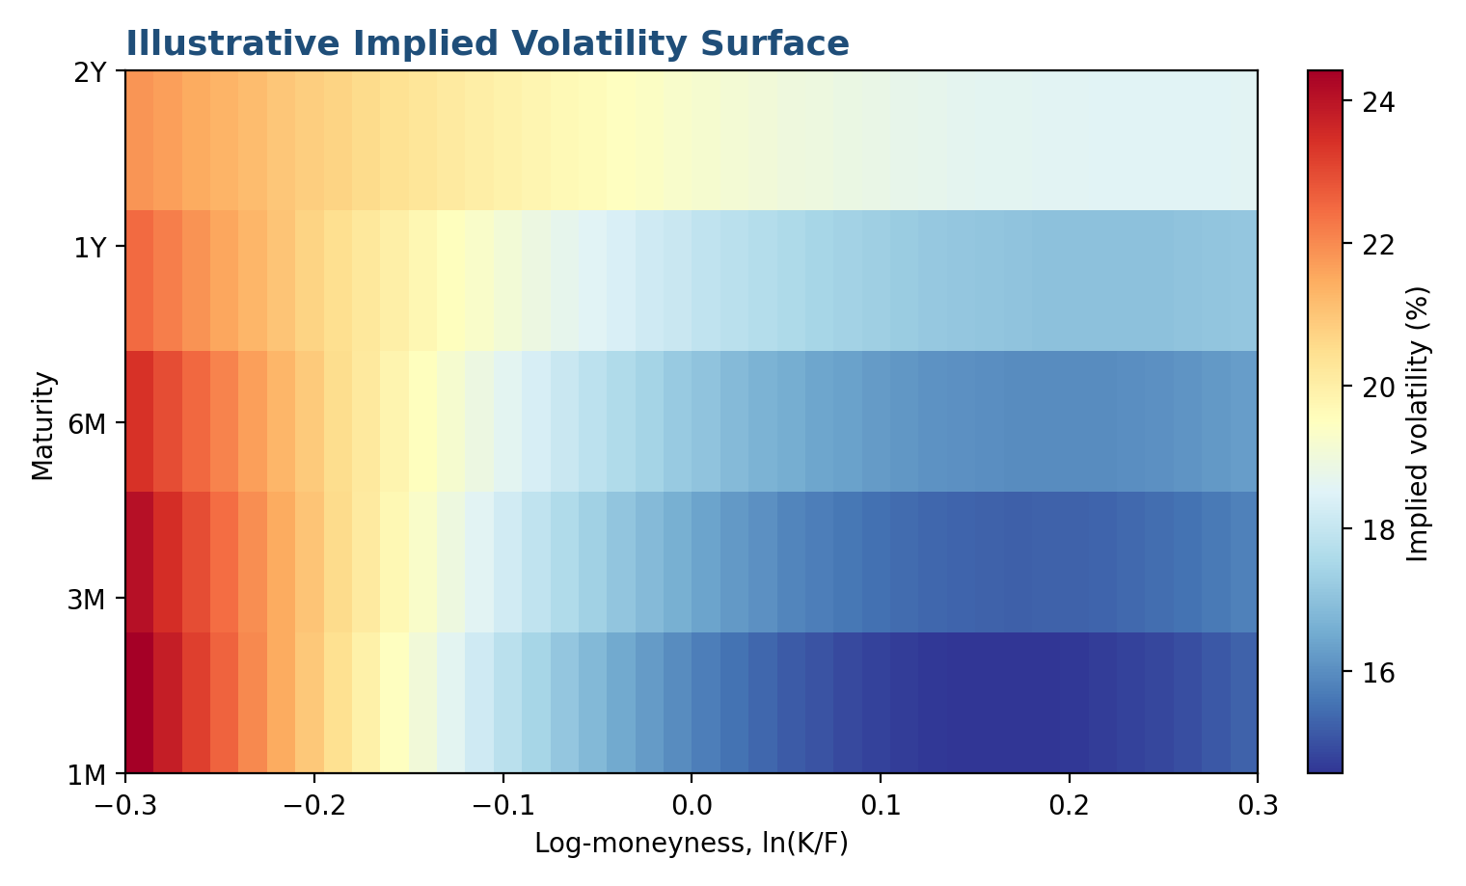
Figure 3.2. An illustrative implied volatility surface across log-moneyness and maturity. The skew is steep and the level is high at short maturities, and both flatten and compress as maturity increases.

3.4 Parameterizing the Surface: SVI
Because a surface must be interpolated between listed strikes and maturities, and because naive interpolation can accidentally introduce arbitrage (a butterfly or calendar spread that is negatively priced), practitioners fit the surface to a parametric form. The most widely used is Gatheral's stochastic volatility inspired (SVI) parameterization, which models total implied variance as a function of log-moneyness k at a fixed maturity:
w(k) = a + b × (ρ(k − m) + √((k − m)² + σ²))
The five parameters (a, b, ρ, m, σ) control the overall level, the wing slopes, the skew and the curvature of the smile, and can be constrained to guarantee no static arbitrage across strikes at a single maturity. Extending this consistently across maturities — so that the surface is also free of calendar-spread arbitrage — is a standard piece of infrastructure on any options desk, and a recurring research topic in its own right.

Part 4 — Volatility as an Asset Class
Volatility is not only an input to pricing other instruments — it is directly tradable in its own right, through variance swaps, the VIX complex, and options positions constructed specifically to isolate exposure to volatility rather than to the direction of the underlying.

4.1 The VIX and Variance Swap Replication
A variance swap is a forward contract on realized variance: at maturity, one side pays the difference between realized variance over the period and a fixed strike agreed at inception. Its fair strike can be replicated model-free from a static strip of out-of-the-money options, weighted by the inverse square of the strike — the same insight that underlies the modern, model-free construction of the VIX:
K_var ≈ (2/T) × Σᵢ (ΔKᵢ / Kᵢ²) × e^(rT) × Q(Kᵢ) − (1/T)(F/K₀ − 1)²
VIX = 100 × √K_var (with K_var interpolated to a constant 30-day horizon)
Since 2003, the CBOE has computed the VIX this way — as the fair strike of a 30-day variance swap on the S&P 500, interpolated between the two nearest listed expiries — rather than from at-the-money Black-Scholes implied volatility as in the original 1993 methodology. Because the replication sums over the whole strike range weighted by 1/K², the VIX embeds the skew from Section 3.2: a steeper put skew mechanically raises the index, independent of at-the-money implied volatility alone.
Tip: The lower-strike weighting in variance-swap replication means the VIX is not simply ‘the market's view on at-the-money volatility’ — it is a variance-weighted average across the whole skew, which is why it can move even when at-the-money implied volatility barely changes.

4.2 The Volatility Risk Premium
Averaged over time, implied volatility tends to exceed the volatility that subsequently realizes — the volatility risk premium (VRP). This is usually interpreted as compensation for bearing tail risk: sellers of variance are effectively selling insurance against large, sudden moves, and demand a premium for it, in the same way an insurer prices a policy above its actuarially fair value. The VRP is not a constant, however, and can compress sharply or turn briefly negative during genuine stress, when realized volatility spikes faster than implied volatility can be repriced.
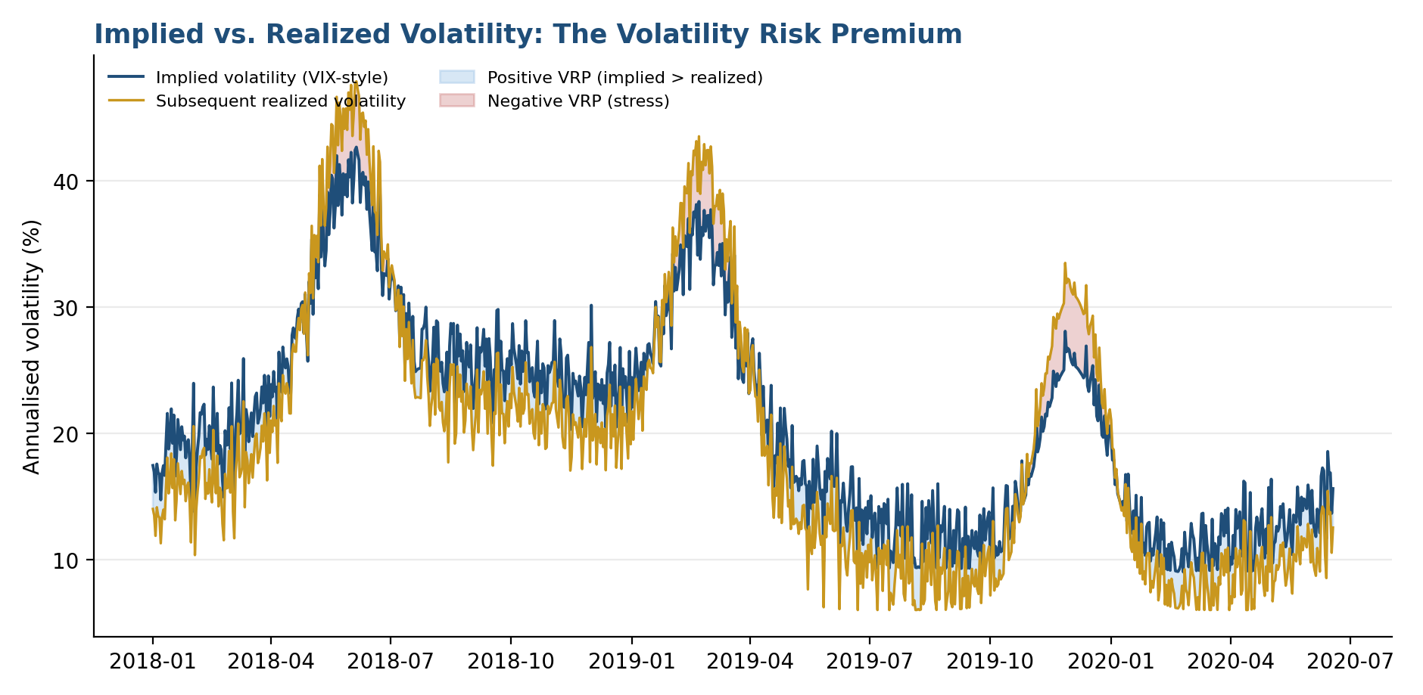
Figure 4.1. Implied volatility (VIX-style) versus subsequently realized volatility. The premium is typically positive (shaded blue) but compresses or turns briefly negative during acute stress (shaded red), when realized volatility overshoots what was priced in.

4.3 Trading Volatility
A range of strategies are built directly on the concepts above:
- Volatility arbitrage — delta-hedged options positions designed to isolate the gap between implied and subsequently realized volatility, harvesting the volatility risk premium (or betting against it).
- Dispersion trading — selling index volatility while buying the volatility of the index's constituents (or vice versa), expressing a view on implied correlation rather than on volatility levels directly.
- Volatility carry — systematically selling short-dated variance swaps or VIX futures to collect the risk premium, typically overlaid with tail-risk hedges given the strongly negatively skewed payoff of being short volatility.
- Calendar and skew trades — positions that isolate the term-structure or skew dimensions of the surface directly, rather than its overall level.
Common mistake: Treating short-volatility carry strategies as a steady income stream rather than as a strategy with a strongly negative skew: small, frequent gains most of the time, punctuated by rare, large losses exactly when realized volatility spikes.

Part 5 — Volatility Tracking in Practice
Outside a derivatives desk, volatility tracking is mostly used defensively and structurally — to size positions, to scale risk estimates, and to detect when the market's behaviour has shifted regime. This part covers how the measurement and forecasting tools from Parts 1 and 2 are actually deployed.

5.1 Volatility Targeting in Portfolio Construction
A volatility-targeting rule scales a portfolio's exposure inversely with its forecast volatility, so that realized risk stays close to a fixed target regardless of how calm or turbulent the market currently is:
exposure_t = target_volatility / forecast_volatility_t
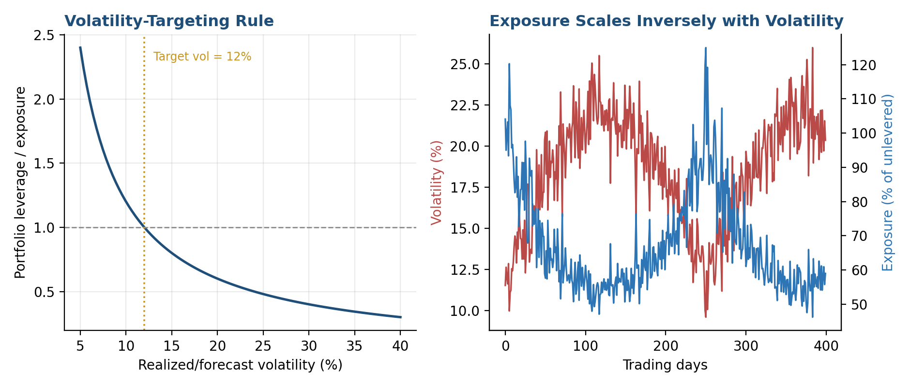
Figure 5.1. Left: a volatility-targeting rule scales exposure inversely with forecast volatility. Right: as market volatility rises and falls, portfolio exposure adjusts in the opposite direction to keep realized risk near target.
This approach, widely used in risk-parity and managed-futures strategies, has an important side effect: because it de-risks mechanically after volatility rises, it can turn a gentle sell-off into forced selling if many participants run similar rules simultaneously, amplifying rather than dampening a downturn. It also tends to reduce a strategy's exposure precisely when volatility (and often expected returns) are highest, a trade-off that needs to be weighed deliberately rather than assumed away.

5.2 Volatility Scaling in Risk Management
Value-at-risk and other risk measures are almost always built by scaling a volatility estimate. A simple parametric VaR at confidence level (1 − α) over horizon h is:
VaR_{1-α, h} = z_α × σ_daily × √h (z_α = the α-quantile of the standard normal distribution)
Because this scaling assumes returns are normally distributed and that volatility itself is stable over the horizon h, VaR built this way tends to understate risk exactly when it matters most — during the fat-tailed, volatility-clustered regimes described in Section 1.4. Well-run risk functions therefore track realized and forecast volatility continuously, rather than as a periodic input, and stress-test the resulting risk numbers against historical spikes rather than trusting the normal-distribution assumption in isolation.

5.3 Regime Detection and Nowcasting
Because volatility clusters and moves through recognisable regimes, a substantial amount of applied work focuses on detecting a regime shift as early as possible — ‘nowcasting’ current volatility rather than only forecasting it forward. Approaches range from simple rules (comparing short-window realized volatility to its long-run average, or tracking the VIX term structure for signs of inversion) to formal regime-switching models that explicitly estimate the probability of being in a high- or low-volatility state at each point in time.
Tip: A VIX term structure that inverts — near-term implied volatility trading above longer-dated implied volatility — is one of the most widely watched practitioner signals that the market has already moved into acute stress, since it reflects immediate demand for near-term protection outpacing longer-term concern.

5.4 Data and Infrastructure Conventions
A production volatility-tracking system depends on the same data discipline introduced elsewhere in this curriculum: consistent annualisation conventions (252 trading days for equities, 365 for always-on markets), clean handling of corporate actions and stock splits before computing historical returns, careful alignment of the risk-free rate and dividend yield used in implied-volatility inversion, and a documented, versioned choice of interpolation method for the volatility surface so that two desks pricing the same option on the same day get the same answer.

Practical Exercise
Build a small volatility-tracking pipeline for a single liquid underlying (a major equity index is easiest, since listed options and a VIX-style benchmark are both available).
- Step 1 — Compute historical estimators: using daily OHLC data, compute close-to-close, Parkinson, Garman-Klass and Yang-Zhang volatility over a rolling window, and compare their relative noise.
- Step 2 — Build and compare forecasts: fit an EWMA (λ = 0.94), a GARCH(1,1), and if intraday data is available, a HAR-RV model, and forecast one day ahead throughout your sample.
- Step 3 — Evaluate out-of-sample: score each forecast against subsequently realized volatility using mean squared error, and identify the periods where the models disagree most.
- Step 4 — Extract implied volatility: using listed option prices for the same underlying, invert Black-Scholes to build a simple smile at one maturity, and compare its level to your realized-volatility estimates from Step 1.
- Step 5 — Apply a volatility-targeting rule: scale a simple buy-and-hold position by target volatility divided by your Step 2 forecast, and compare the realized volatility and drawdown of the scaled position to the unscaled benchmark.
Tip: Pay particular attention to how each forecasting model behaves immediately after a volatility spike in Step 3 — this is where EWMA, GARCH and HAR-RV are most likely to visibly disagree, and the disagreement is itself instructive.

Common Beginner Mistakes
Mistake 1 — Treating volatility as directly observable. Volatility is always an estimate or a model output, never a directly observed quantity like a price. Different estimators, windows and models applied to the exact same data will legitimately disagree, sometimes substantially.
Mistake 2 — Confusing implied and realized volatility. Implied volatility is a market-implied, forward-looking price quantity; realized volatility is a backward-looking statistical measurement. Comparing them is informative (see the volatility risk premium in Section 4.2), but treating them as the same quantity measured two ways is a common and consequential error.
Mistake 3 — Using close-to-close volatility when better data is available. If OHLC or intraday data exists, close-to-close volatility throws away real information. Range-based or realized estimators are more efficient for the same historical window and should be preferred wherever the data supports them.
Mistake 4 — Ignoring the mean-reversion and persistence properties of the chosen model. An EWMA forecast with no mean-reversion target will stay elevated long after a shock has genuinely passed; a GARCH model with α + β too close to one will imply persistence that may not hold up out-of-sample. Understand what your chosen model assumes about how volatility decays.
Mistake 5 — Assuming volatility scaling with the square root of time always applies. The √h scaling used in simple VaR formulas assumes returns are independent and identically distributed through time — an assumption that volatility clustering directly violates. Scaling short-horizon volatility up to a longer horizon this way can materially understate risk over horizons that span a regime change.
Mistake 6 — Treating a short-volatility carry strategy's smooth track record as evidence of low risk. Strategies that systematically sell volatility typically show a long run of small, steady gains punctuated by rare, sharp losses. A smooth historical Sharpe ratio built mostly from the calm periods says little about the size of the tail risk being carried.

Advanced Extensions
Beyond the estimation and forecasting approaches covered here, volatility research extends in several directions. Stochastic volatility models such as Heston (1993) and the SABR model treat volatility itself as a random process correlated with the underlying, generating the smile and skew endogenously rather than fitting them after the fact; both remain industry standards for pricing and risk-managing options books. More recently, the discovery that log-volatility behaves like a fractional Brownian motion with a Hurst exponent of roughly 0.1 — far rougher than the smooth diffusions assumed by classical models — has motivated a new generation of rough volatility models (Gatheral, Jaisson and Rosenbaum, 2014/2018) that better match the observed term structure of at-the-money skew using fewer parameters. On the forecasting side, machine-learning approaches (gradient-boosted trees, LSTMs and related architectures trained on realized-volatility and order-book features) are an active area of research, generally evaluated against the HAR-RV benchmark covered in Section 2.3 rather than replacing it outright. Finally, jump-diffusion models and cross-asset volatility spillover analysis extend the single-asset toolkit of this module toward the multi-asset and tail-risk questions revisited at Level 5.

Professional Applications
- Derivatives pricing and market making — options desks live and die by the accuracy of their volatility surface and its consistent, arbitrage-free interpolation.
- Risk management — volatility forecasts scale value-at-risk, margin requirements and stress-testing scenarios across every desk in a firm.
- Portfolio construction — volatility targeting and risk-parity approaches use forecast volatility directly to size positions and allocate capital.
- Volatility trading — variance swaps, VIX futures and options, and dispersion trades exist specifically to express a view on volatility, correlation or the volatility risk premium.
- Systematic and macro strategies — regime detection built on realized and implied volatility informs macro positioning, trend-following exposure and tail-risk hedging programmes.

Where to Go Next
This module has covered how to measure volatility from historical and high-frequency data, how to forecast it using EWMA, GARCH and HAR-RV, how implied volatility and the volatility surface are constructed and traded, and how volatility tracking is applied in portfolio construction and risk management. Where you go next depends on which side of the work you are heading toward.
- For research: continue toward stochastic and rough volatility models, and toward formal regime-switching frameworks that build directly on Section 5.3.
- For development: focus on the data and infrastructure conventions in Section 5.4 — a volatility-tracking system is only as good as its data discipline.
- For trading: build on Part 4 by studying variance-swap and dispersion desks in more depth, with explicit attention to the tail risk described in Section 4.3.
Tip: Whichever path you take, revisit this module at Level 5, where stochastic and rough volatility models, and multi-asset volatility contagion, build directly on the foundations covered here.

